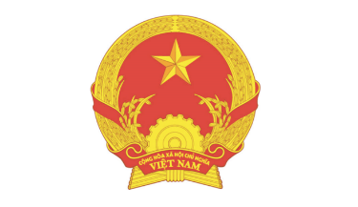  VIETNAM EMBASSY IN RUSSIAN FEDERATION  TRADE OFFICE | 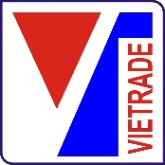  MINISTRY OF INDUSTRY AND TRADE  VIETNAM TRADE PROMOTION AGENCY
VIETNAM – RUSSIA WEBINAR AND ONLINE BUSINESS MATCHING:
“PROMOTING TRADE COOPERATION IN THE FIELDS OF CONSTRUCTION AND FURNITURE”

Date : Thursday, 15th July 2021
Time (Vietnam) : 14h00 – 19h00
Time (Russia) : 10h00 – 15h00
10:00 - 10:10 | Welcoming Speech  Leader of Vietnam Trade Promotion Agency, VIETRADE,  MOIT
10:10 – 10:20 | Opening Speech  Representative of the Embassy of Russian Federation in Hanoi
10:20 – 10:40 | Speech  The trade cooperation situation between Vietnam and Russia in the context of Covid-19, focusing on the fields of construction and furniture  Representative of Vietnam Trade Office in Russia
10:40 – 11:00 | Speech  Russian enterprises introduction and the import and export demands of Russian enterprises, focusing on construction and furniture sector  Representative of Russian Chamber of Industry and Commerce
11:00– 11:30 | Q&A
11:30 – 15:00 | Business matching
TENTATIVE PROGRAM

